1. 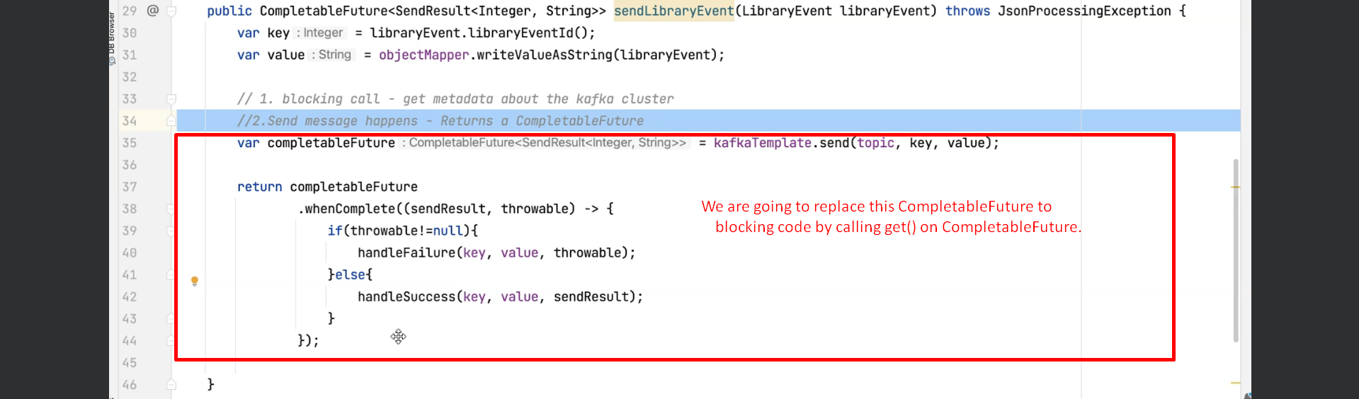
2. 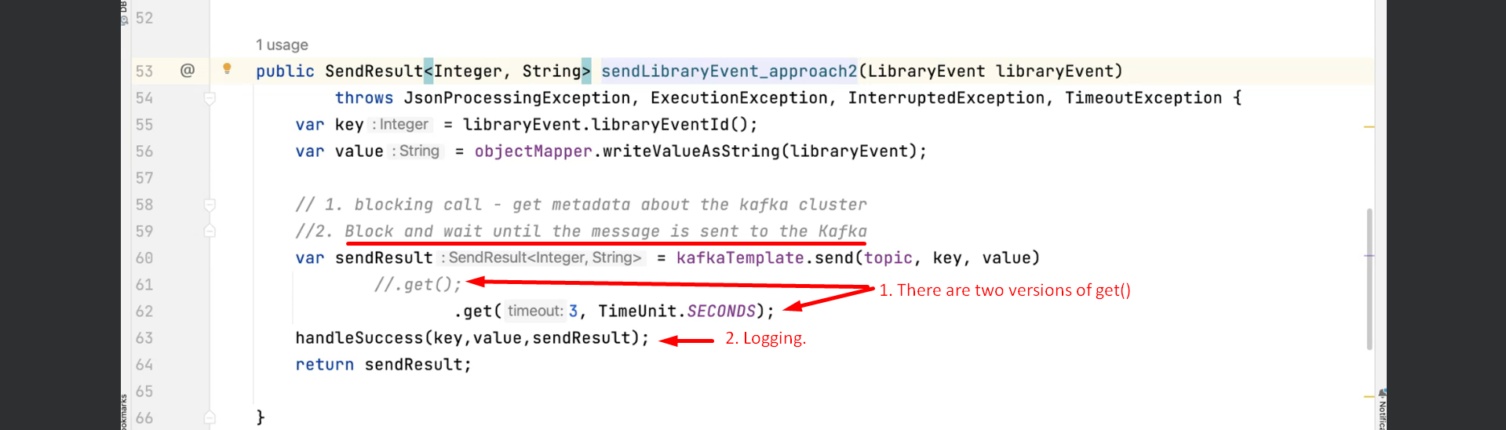  
   It is better to have asynchronous call so that our clients are not going to experience any failure when these Kafka calls fail.

There is section in the future part of the course that handles about how to handle the Kafka failures and what are the different options that we have to handle these Kafka Failure gracefully.

1. In the above code, if there is any failure, the error msg will be sent to the client instead of status Code 201 (Created).